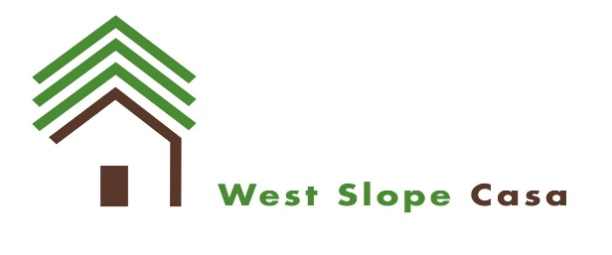

COVID Relief MSO Funding Request
West Slope Casa (WSC), in order to ensure access to substance use treatment, prevention, and recovery services during a period of increased need and significant disruption due to the COVID-19 pandemic, is offering financial support to treatment and recovery service providers.
Agencies located in the following regions are eligible for this funding:
- SSPA 5 (Southwest Colorado): Archuleta, Delta, Dolores, Gunnison, Hinsdale, La Plata, Montezuma, Ouray, San Juan, and San Miguel Counties
- SSPA 6 (Northwest Colorado): Eagle, Garfield, Grand, Jackson, Mesa, Moffat, Pitkin, Rio balance, Routt, and Summit Counties
Agencies must meet the minimum requirements to apply for this funding:
- Substance Use Disorder (SUD) Treatment Service Provider: Must be OBH licensed, Medicaid treatment provider and serve indigent clients (those without a payor source and up to 300% of household Federal Poverty Level.
- SUD Recovery Services:
  - Recovery Living communities must be Oxford House chartered or CARR certified (levels I, II, or III)
  - Recovery service providers must:
    - Meet the definition of a recovery community organization (RCO), “An independent, non-profit organization led and governed by representatives of local communities of recovery. (Such organizations carry out recovery-focused community education and outreach programs, and/or provide peer-run recovery support services).”
    - Or, offer recovery services at an OBH-licensed treatment provider.
Additional information may be requested by Signal prior to approval of funding.

Funding criteria
Providers interested in accessing this funding support should submit a request for funds along with a capacity-based budget template. Funding may be requested for qualified expenses going back to July 1, 2020 and extending through December 30, 2020 for support of the following categories (direct expense requests will carry higher priority than sustainability subsidy requests):

1. Direct COVID-19 related expenses
- Personal Protective Equipment (PPE) for staff of clients and training on use of PPE
- Cleaning supplies or services
- Telehealth equipment, services, training, and support
- Trainings on disease prevention
- Upgrade facilities and procedures to accommodate distancing and separation, and enhance infection control
- Staff support (documentation of staff receiving funds will be required)
  - Critical care staff monthly stipends (up to $500/mo. above base pay) Critical care staff is defined as those staff that are working in the following programs: withdrawal management programs, residential programs, opioid treatment programs, Medication Assisted Treatment, Recovery Community Organizations, and Recovery Housing Programs.
  - Paid sick leave, paid leave for mandatory quarantine, supplemental payroll for normal hours unable to work due to COVID-19 constraints, or funds for temporary staff to cover for those on quarantine
  - Overtime pay related to COVID-19 impact
- Transportation
- Capacity to treat clients who are COVID-19 positive in SUD bed-based programs (residential and withdrawal management)
- Employment assistance for clients displaced from the workforce
- Support of Recovery Residences through employment assistance or support of resident housing costs due to COVID-19 disruptions and job loss
  - Rental support cannot exceed $800 per month per resident and associated overhead expenses cannot exceed $150 per month per resident

2. Sustainability of Services, Due to COVID-19 Impacts
Sustainability funding for critical services with impacts attributed to disruption from COVID-19 (for example, a reduction in program census, public health order changes, etc.). Budgeting will use the OBH capacity budget.

Funding request
Please submit questions in regards to this offering to proposals@westslopecasa.org.
Please submit the funding request form and capacity based budget template to proposals@westslopecasa.org by 5pm October 5. If there are no follow-up clarifications necessary, Agency will receive a contract or contract amendment from Signal indicating the amount of funding that is approved.
WSC has limited available funds and will continue to release additional offerings as funds are available. WSC may revise budgets based on available funds or other factors.

Invoicing
If funding is approved, providers will be asked to submit a monthly invoice for these additional allowable expenses that is derived from the submitted and accepted budget.

